SQL Exercise 5

**Purpose:** Nine SQL exercises will be released throughout the quarter. These assignments will help you connect and manipulate a database through Python. Python-to-SQL is a parallel strand of knowledge that you would gain in this class.

**Reference:** 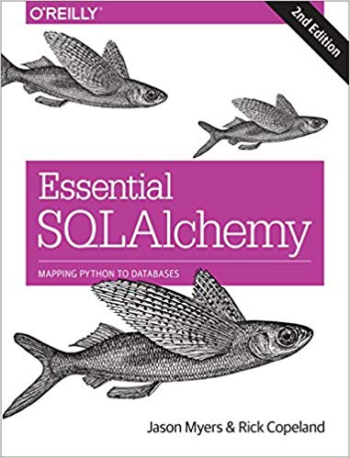

**Code:** Time to practice! Try the code below and get it to work. The code is pre-tested and should run “as is.” Verify what you type if an error persists. Press “Run” to every time you completed a jupyter cell. Because you already have content knowledge of what is a database, most of the code are self-explanatory.

***Instructions:*** *Start a new Python project folder … do not reuse the previous workspace … As with any keyboard-driven console-like environment, developing muscle -memory for the common commands is also part of the learning curve.*

**Viewing database:** To view the database created by Python, you may use a SQL Lite viewer. This tool is posted inside Week #2 in Canvas; look for DB.Browser.for.SQLite-3.10.1-win64

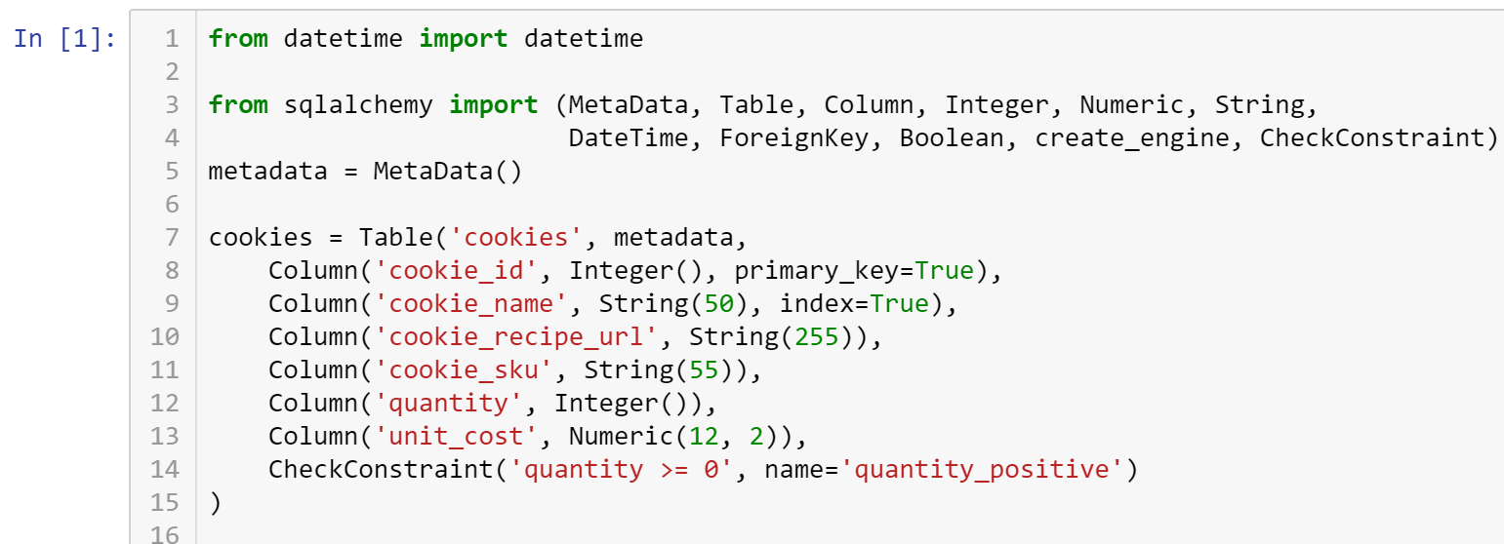

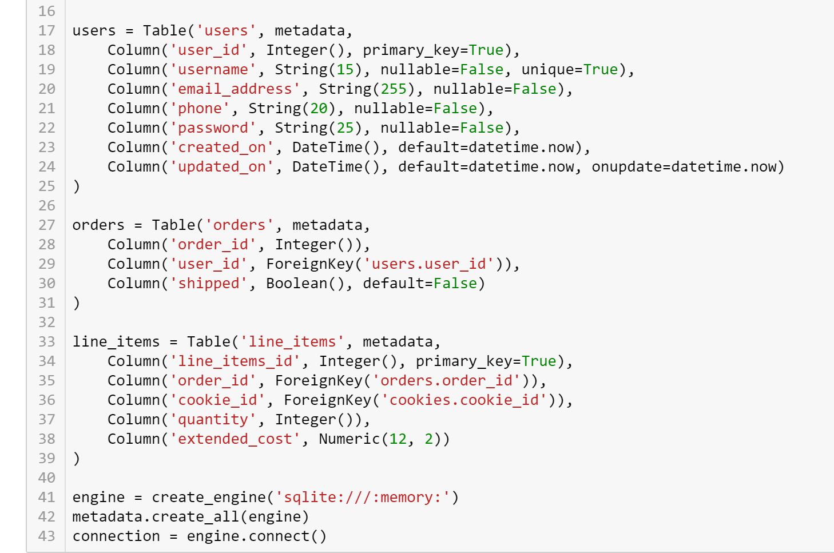

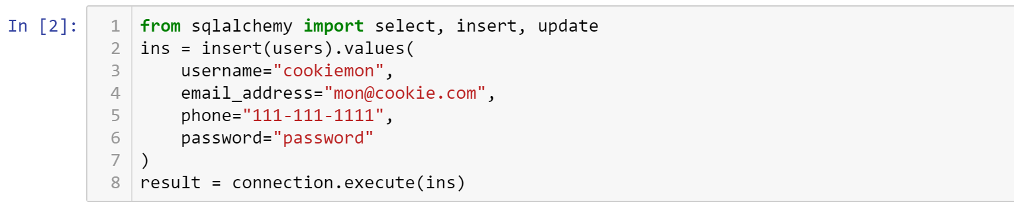

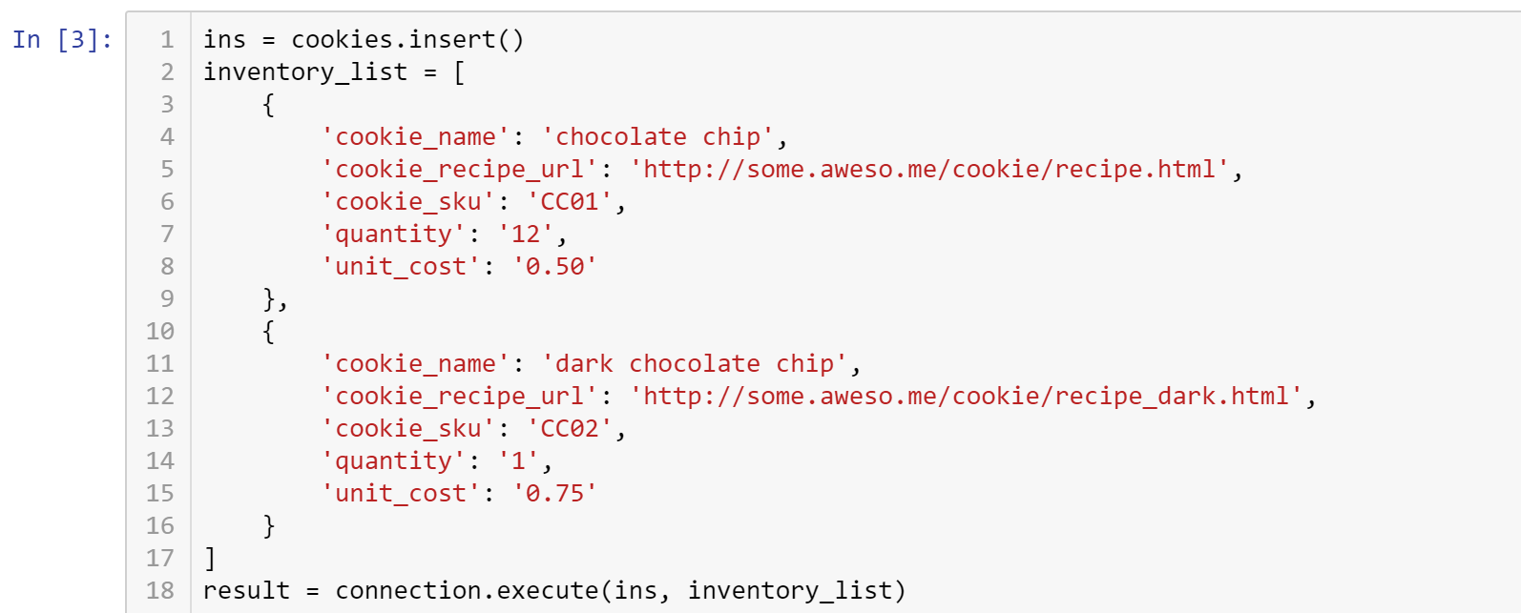

If you run this SQL again, you may get an error due to duplicate entries.

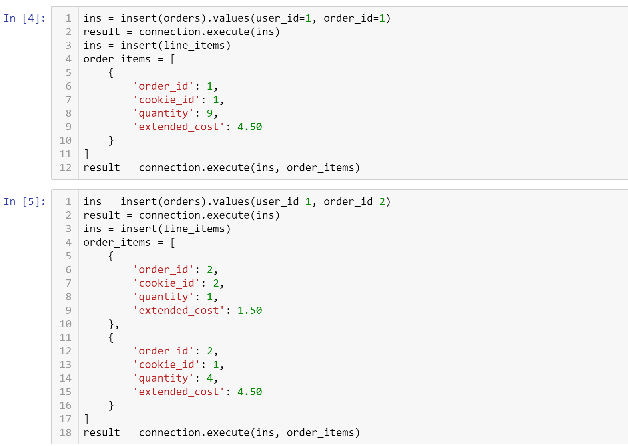

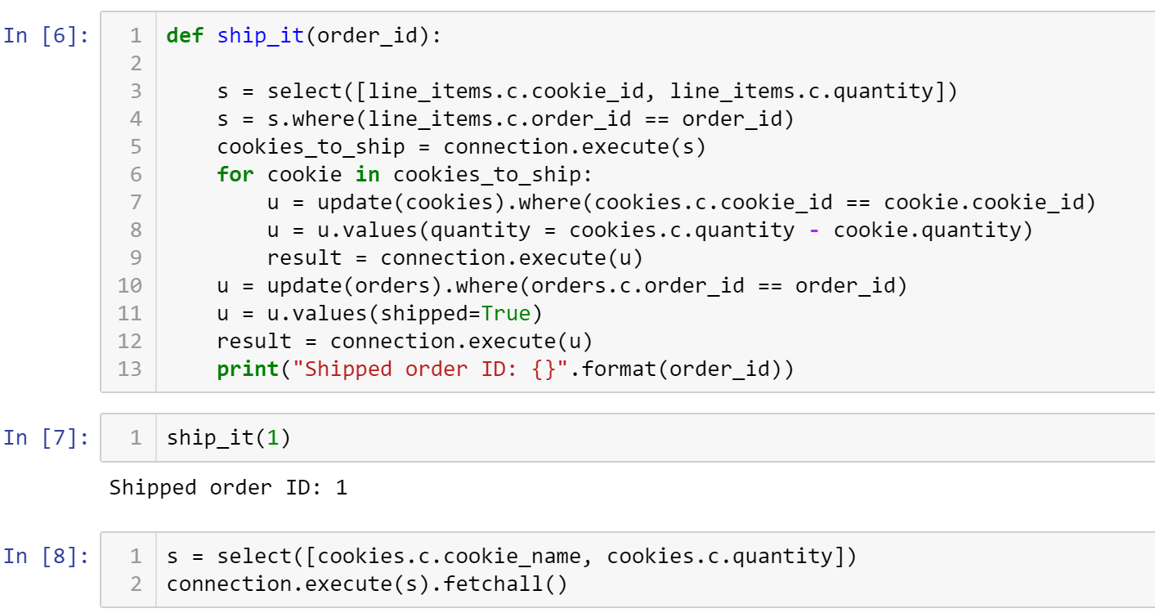





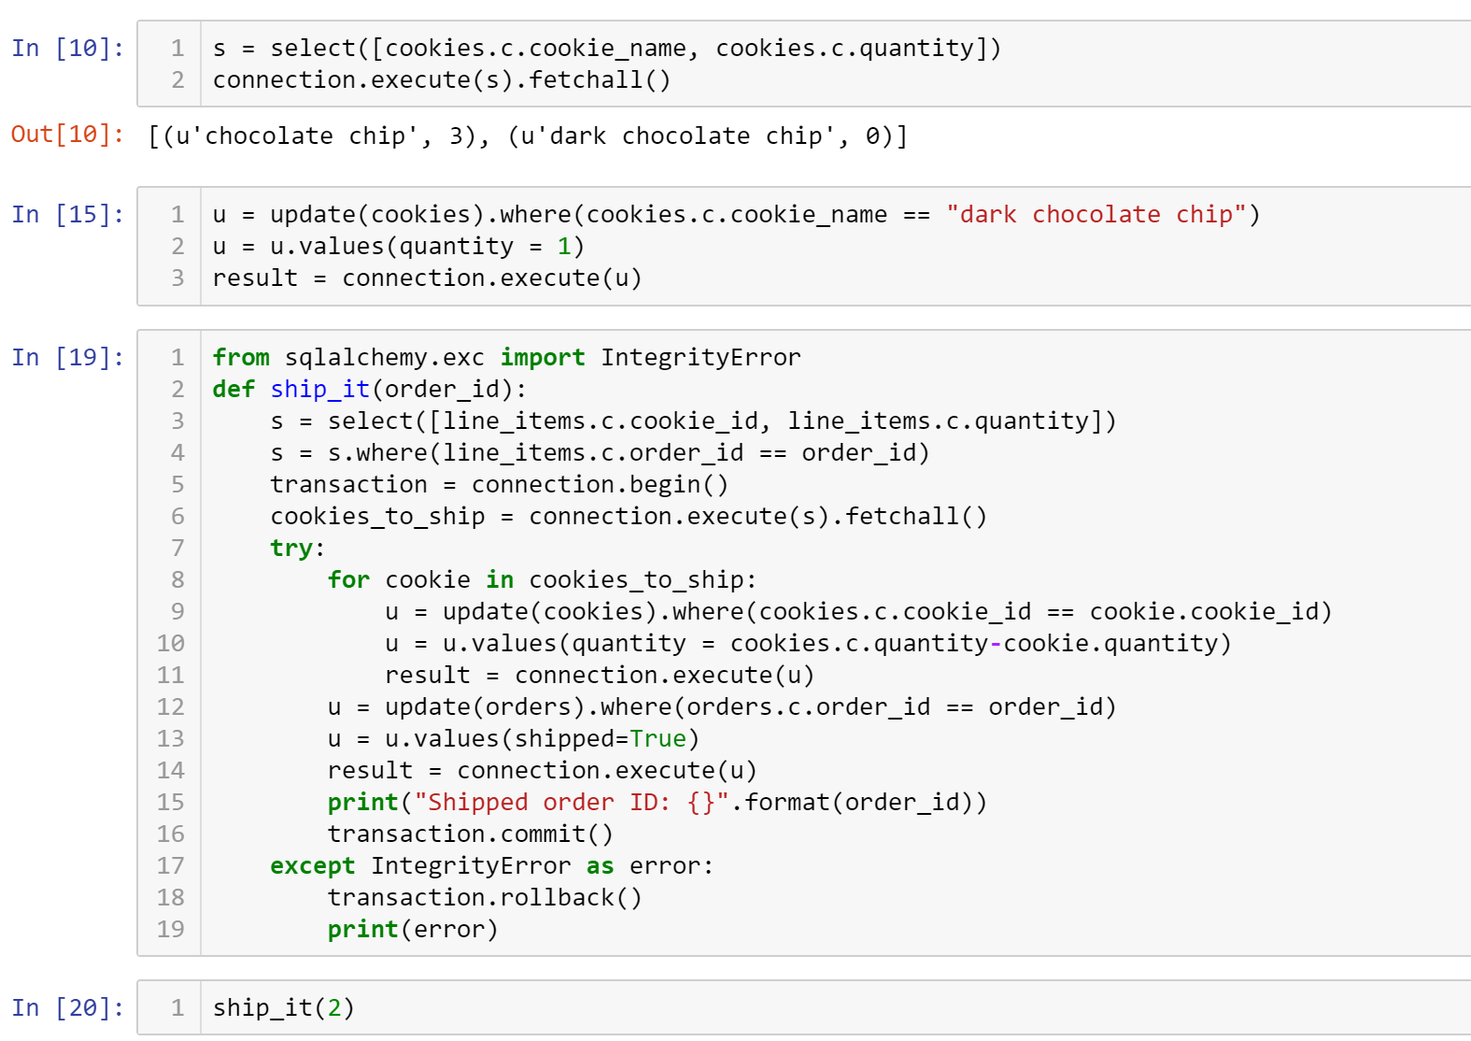

(sqlite3.IntegrityError) CHECK constraint failed: quantity_positive [SQL: u'UPDATE cookies SET quantity=(cookies.quantity - ?) WHERE cookies.cookie_id = ?'] [parameters: (4, 1)]

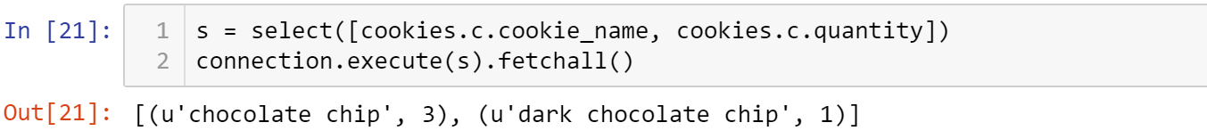

* **Critical Thinking Section:** In your own words, write a paragraph (5 sentences or more) describing how you would save your data from Python without using a database? In other words, what are alternative means you can use to store your Python information?
* Place your answer here below:

|  |
| --- |
|  |

* Place your name at the bottom of your code, download your Python program in html format, and submit your work in Canvas.

**Viewing database:** To view the database created by Python, you may use a SQL Lite viewer. This tool is posted inside Week #2 in Canvas; look for DB.Browser.for.SQLite-3.10.1-win64

**Important:** All submissions should be separate from other exercises and quests. Please do not lump all your answers into one document and re-using that same workspace to gain multiple points. Thanks.